**Profile Creation**

1. Set the environment and execute the below script

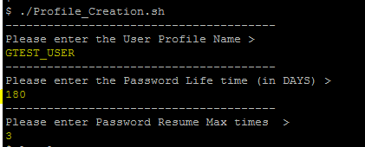

1. Enter Profile name, which we want to create and password lifetime, password reuse time details as mentioned above.
2. Once the script executed, Profile will be automatically created and it will generate a confirmation mail

